Indias Agricultural Crop Production Analysis
Abstract
Agriculture is one of the most important sectors of the Indian economy, contributing significantly to employment, food security, and national development. With agricultural data being generated across different states, crops, seasons, and years, analyzing this information manually is challenging and time-consuming. The objective of this project is to transform raw agricultural data into meaningful insights through interactive data visualization using Tableau.
The dataset used in this project was collected from Kaggle and contains 345,408 records and 10 attributes, covering agricultural crop production across India from 1997 to 2021. The dataset was first examined and prepared in Microsoft Excel, where data consistency was verified and an additional Yield column was created by calculating the ratio of production to cultivated area. The cleaned dataset was then imported into Tableau Public for visualization.
A series of interactive visualizations were developed to analyze different aspects of agricultural production, including KPI cards for Total Production and Total Yield, year-wise yield trends, state-wise production distribution using an India choropleth map, crop-wise production analysis, cultivated area comparison across states, leading agricultural states, year-wise production trends, production distribution by unit type, and season-wise production share. These visualizations were integrated into a professional dashboard with interactive filters, enabling users to explore agricultural data dynamically. A Tableau Story was also created to present the analysis in a structured narrative and effectively communicate the key findings.
Finally, the completed dashboard was published to Tableau Public and integrated into a Flask web application to improve accessibility and provide an interactive web-based interface. The analysis highlights production patterns, regional differences, and long-term agricultural trends, making the dashboard useful for students, researchers, policymakers, and agricultural planners. Overall, this project demonstrates how Tableau can convert complex agricultural datasets into intuitive, interactive, and data-driven visualizations that support informed decision-making.

1.Introduction
Agriculture plays a vital role in India's economy by providing employment and contributing significantly to the nation's GDP. Due to the vast amount of agricultural data generated every year, it becomes difficult to analyze production trends using raw spreadsheets. This project uses Tableau to transform agricultural data into interactive dashboards and stories, making the information easier to understand and analyze.
2. Problem Statement
The agricultural dataset contains thousands of records collected over several years across different states, crops, and seasons. Analyzing this data manually is difficult and time-consuming. The objective of this project is to build an interactive Tableau dashboard that enables users to analyze agricultural production, cultivated area, crop performance, seasonal distribution, and year-wise trends through meaningful visualizations.
3. Objectives
- Analyze agricultural crop production from 1997–2021.
- Compare crop production across Indian states.
- Study cultivated area by state and crop.
- Analyze year-wise agricultural yield.
- Identify leading agricultural states.
- Build an interactive Tableau dashboard.
- Create a Tableau Story for data presentation
4. Dataset Collection
Dataset Source
The dataset was downloaded from Kaggle.
Dataset Name : India's Agricultural Crop Production (1997–2021)
Dataset Information
- Rows: 345,408
- Columns: 10
- Size: Approximately 28 MB

Steps Performed
- Downloaded the dataset from Kaggle.
- Extracted the dataset.
- Opened the Excel file.
- Verified all columns.
- Checked data consistency.
6. Tools & Technologies Used
Tool | Purpose
Microsoft Excel | Data preparation
Tableau Public | Dashboard development
GitHub | Project repository
Flask | Web integration
VS Code | Flask development
Task 1: Problem Statement & Dataset Collection
Objective
Explain the real-world problem and identify the dataset required for analysis.
Description
Agriculture is one of the major contributors to India's economy. However, analyzing agricultural production across multiple states, crops, and years is difficult using raw data. Therefore, this project aims to build an interactive Tableau dashboard to visualize production, yield, cultivated area, seasonal distribution, and state-wise performance.
Dataset
- Source: Kaggle
- Dataset Name: India's Agricultural Crop Production (1997–2021)
- Rows: 345,408
- Columns: 10
Steps Performed
- Downloaded the dataset from Kaggle.
- Imported it into Tableau.
- Verified the dataset structure.
- Checked column names and data types.
Screenshot:
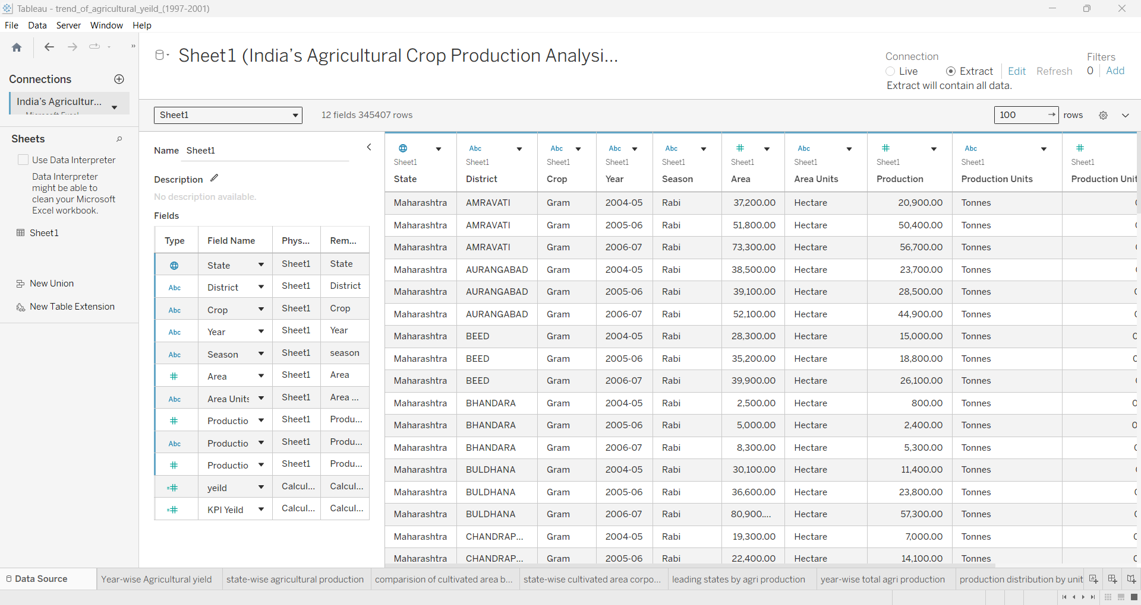
Task 2: Data Cleaning & Preparation
Objective
Prepare the dataset for visualization.
Description
The dataset was examined for inconsistencies before creating visualizations.
Steps Performed
- Verified data types.
- Checked for missing values.
- Verified duplicate records.
- Converted numeric fields where necessary.
- Created an Extract for better performance.
- Verified Measures and Dimensions.
Screenshot:


Task 3 – Visualization Development
Subtask 1: KPI – Total Production
Objective
To display the overall agricultural production of India in a single KPI card, providing users with a quick overview of the total production available in the dataset.
Description
A KPI card was created using the Production measure to represent the total agricultural production. The value was formatted in millions for better readability and displayed prominently at the top of the dashboard.
Fields Used
- Measure: Production
Chart Type
KPI Card (Text)
Steps Performed
- Opened a new worksheet.
- Dragged the Production field to the Text Marks card.
- Changed the aggregation to SUM.
- Formatted the value into Millions.
- Increased the font size and applied bold formatting.
- Added the worksheet title as Total Production.
Result
The KPI displays the total agricultural production of 330,997.84 Million units, providing an instant summary of India's agricultural output.
Screenshot
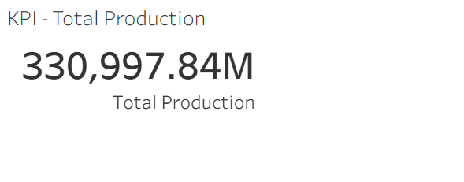
Subtask 2: KPI – Total Yield
Objective
To display the total agricultural yield calculated from the dataset, allowing users to understand the overall productivity.
Description
The Yield field was created in Microsoft Excel before importing the dataset into Tableau. The KPI card displays the total yield calculated from all agricultural records.
Fields Used
- Measure: Yield
Chart Type
KPI Card (Text)
Steps Performed
- Created the Yield column in Excel.
- Imported the updated dataset into Tableau.
- Dragged the Yield field to the Text Marks card.
- Aggregated the field using SUM.
- Formatted the value.
- Added the worksheet title as Total Yield.
Result
The KPI provides a quick overview of the total agricultural yield across the entire dataset.
Screenshot
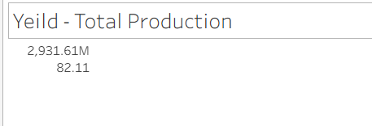
Subtask 3: Trend of Agricultural Yield (1997–2021)
Objective
To analyze how agricultural yield has changed over time from 1997 to 2021.
Description
A line chart was created to visualize the trend of agricultural yield across different agricultural years. This visualization helps identify periods of growth, decline, and stability.
Fields Used
- Dimension: Agricultural Year
- Measure: Yield
Chart Type
Line Chart
Steps Performed
- Opened a new worksheet.
- Dragged Agricultural Year to the Columns shelf.
- Dragged Yield to the Rows shelf.
- Changed the Marks type to Line.
- Formatted the axes and labels.
- Added chart title.
Result
The visualization clearly shows the year-wise trend in agricultural yield, enabling users to analyze productivity changes over the years.
Screenshot
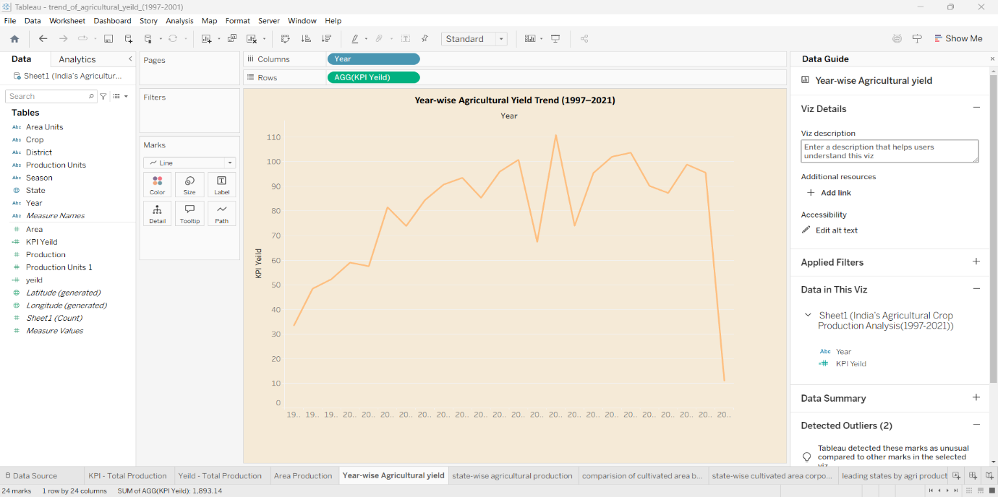
Subtask 4: State-wise Agricultural Production Distribution
Objective
To visualize agricultural production across different Indian states using a geographic map.
Description
An India Choropleth Map was created to display production levels for each state. Different color intensities represent different production values.
Fields Used
- Dimension: State
- Measure: Production
Chart Type
Filled Map (Choropleth Map)
Steps Performed
- Dragged State onto the worksheet.
- Tableau automatically generated the India map.
- Dragged Production to Color.
- Added labels and tooltips.
- Applied formatting.
Result
The map highlights production hotspots and enables easy comparison between states.

Screenshot
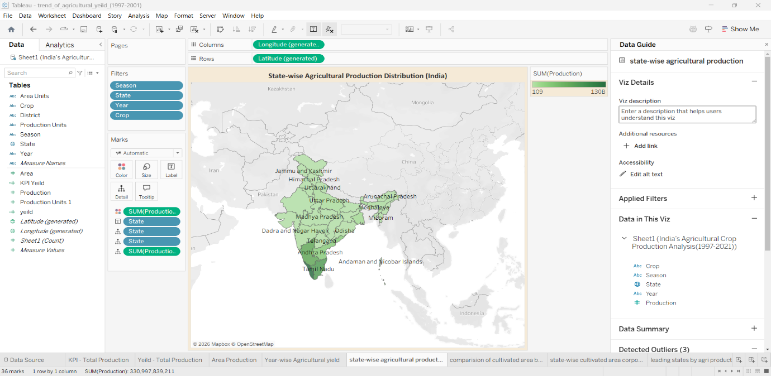
Subtask 5: Crop-wise Total Production Analysis
Objective
To compare agricultural production across different crops.
Description
A horizontal bar chart was created to rank crops according to their total production.
Fields Used
- Dimension: Crop
- Measure: Production
Chart Type
Horizontal Bar Chart
Steps Performed
- Dragged Crop to Rows.
- Dragged Production to Columns.
- Sorted the bars in descending order.
- Applied different colors.
- Added data labels.
Result
The visualization identifies the crops contributing the highest agricultural production.
Screenshot
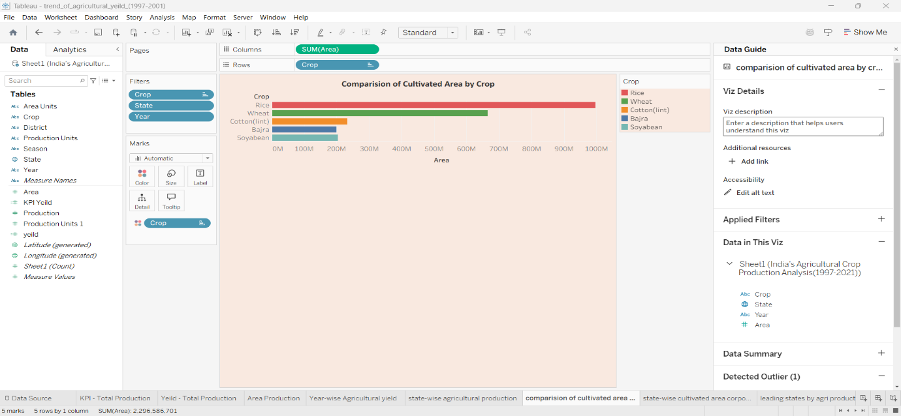
Subtask 6: State-wise Cultivated Area Comparison
Objective
To compare the cultivated area of major crops across different states.
Description
A grouped bar chart was created to compare cultivated area among states based on crop categories.
Fields Used
- Dimension: State
- Dimension: Crop
- Measure: Area
Chart Type
Grouped Bar Chart
Steps Performed
- Dragged State to Columns.
- Dragged Area to Rows.
- Added Crop to Color.
- Sorted the values.
- Formatted the chart.
Result
The visualization compares agricultural land utilization across states.
Screenshot
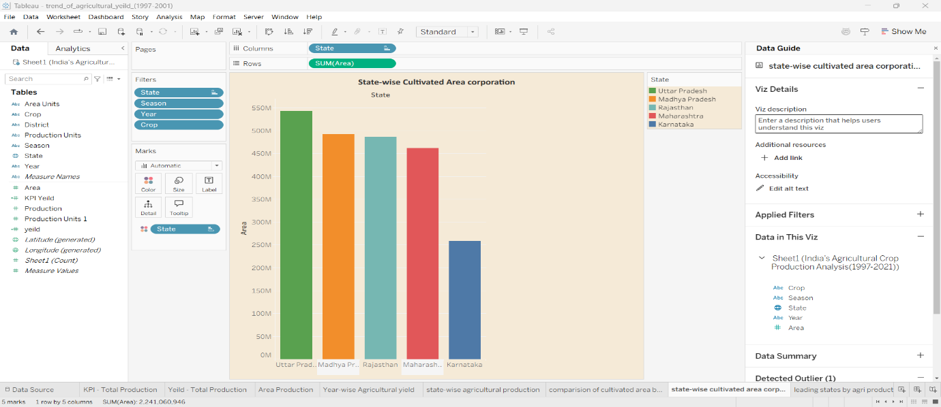
Subtask 7: Leading States by Agricultural Production
Objective
To identify the top-performing states based on agricultural production.
Description
A horizontal bar chart was developed to display the leading agricultural states based on total production.
Fields Used
- Dimension: State
- Measure: Production
Chart Type
Horizontal Bar Chart
Steps Performed
- Dragged State to Rows.
- Dragged Production to Columns.
- Applied Top 5 filter.
- Sorted in descending order.
- Added labels.
Result
The chart highlights the leading agricultural states in terms of total production.
Screenshot
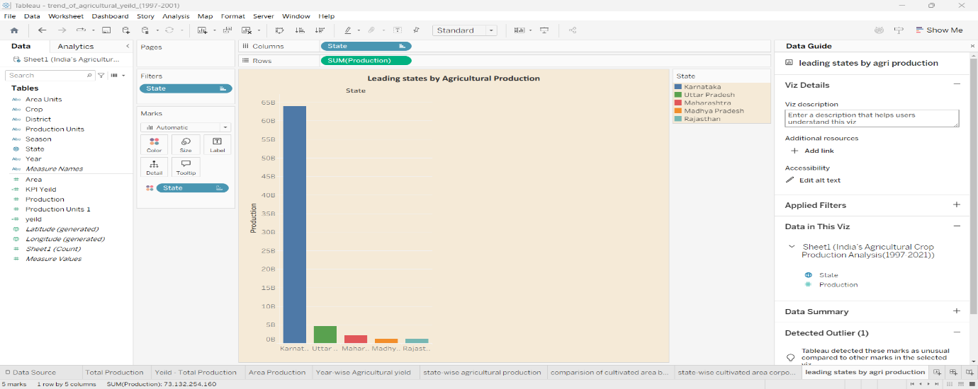
Subtask 8: Year-wise Agricultural Production
Objective
To study agricultural production trends over different agricultural years.
Description
A vertical bar chart was created to compare total production for each agricultural year.
Fields Used
- Dimension: Agricultural Year
- Measure: Production
Chart Type
Vertical Bar Chart
Steps Performed
- Dragged Agricultural Year to Columns.
- Dragged Production to Rows.
- Added Agricultural Year to Color.
- Formatted labels.
- Added chart title.
Result
The visualization shows the increase and variation in agricultural production over the years.
Screenshot
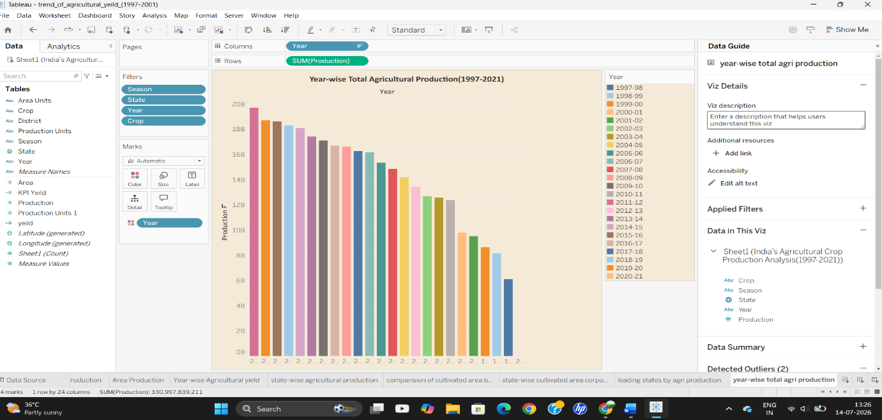
Subtask 9: Production Distribution by Unit Type (Donut Chart)
Objective
To analyze the proportion of agricultural production based on production units.
Description
A donut chart was created to represent the percentage contribution of different production units.
Fields Used
- Dimension: Production Unit
- Measure: Production
Chart Type
Donut Chart
Steps Performed
- Created two pie charts.
- Combined them using a dual-axis.
- Added a white circle in the center.
- Applied colors and labels.
- Formatted the visualization.
Result
The chart clearly shows the distribution of production among different production units.
Screenshot
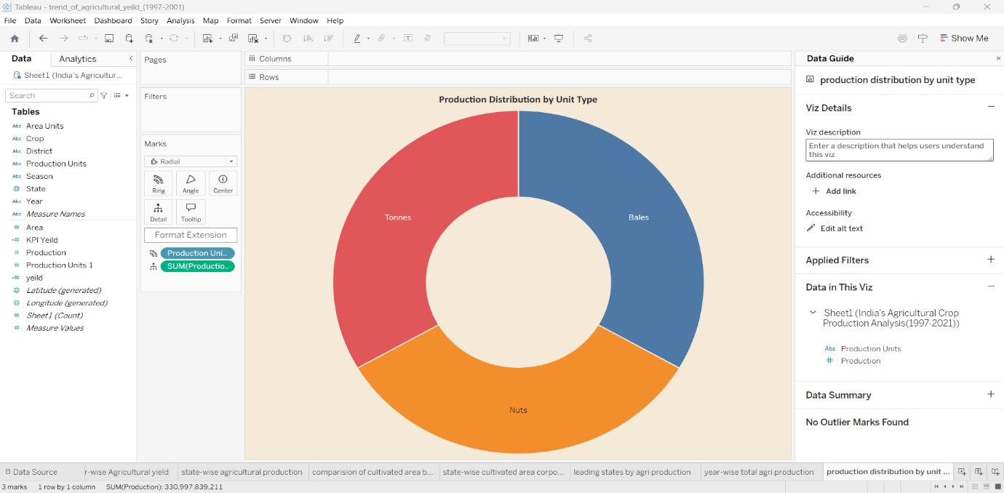
Subtask 10: Season-wise Agricultural Production Share
Objective
To analyze the contribution of different agricultural seasons to the overall production.
Description
A pie chart was created to represent production shares of different agricultural seasons.
Fields Used
- Dimension: Season
- Measure: Production
Chart Type
Pie Chart
Steps Performed
- Dragged Season to Color.
- Dragged Production to Angle.
- Added labels.
- Increased pie size.
- Formatted the chart.
Result
The visualization displays the percentage contribution of each agricultural season to the total production.
Screenshot
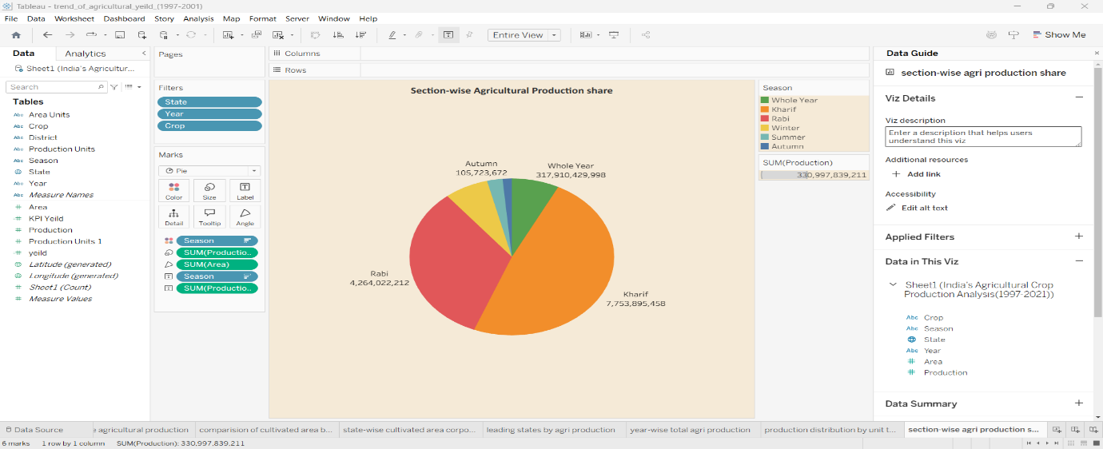
Task 4: Dashboard Development
Objective
Combine all visualizations into a single dashboard.
Steps Performed
- Created a new Dashboard.
- Set the dashboard size.
- Added a beige background.
- Arranged charts in a 2 × 3 layout.
- Added KPI cards.
- Added filters.
- Applied borders and formatting.
Screenshot
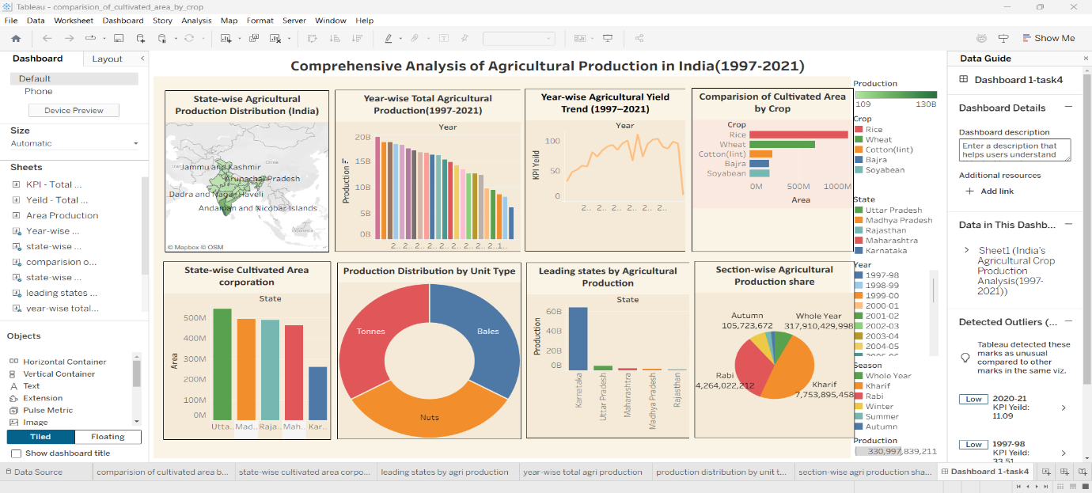
Task 5: Story Creation
Objective
Present the dashboard in a storytelling format.
Steps Performed
- Created a Story.
- Added the Dashboard.
- Added the title.
- Wrote the narrative.
- Explained key insights.
Screenshot
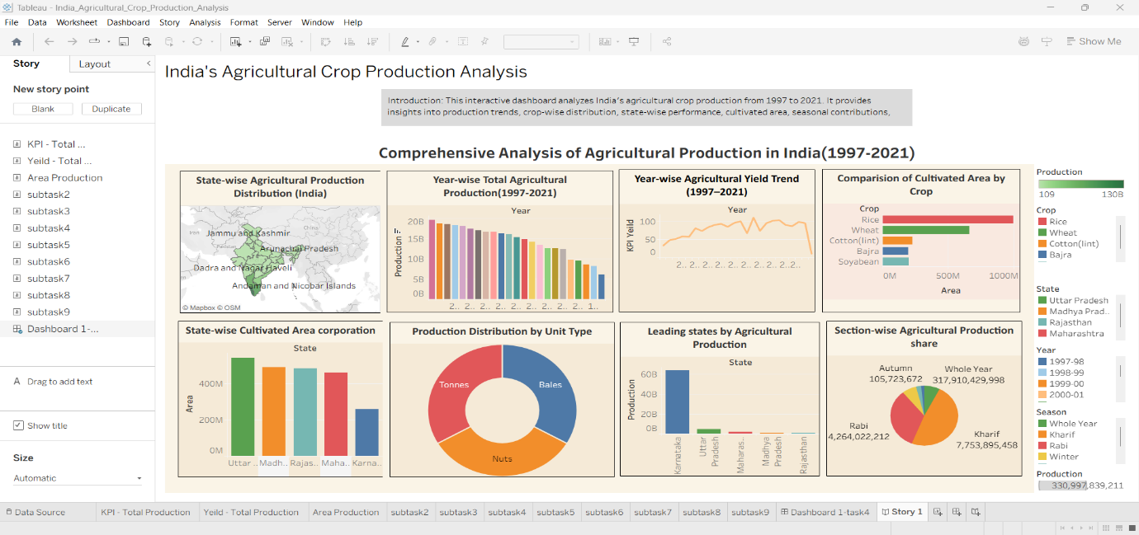

Task 6: Performance & Features
Include:
- Dataset size
- Interactive filters
- Calculated fields (mention whether you used any)
- List of visualizations

Task 7: Publishing & Web Integration
Explain:
- Publishing to Tableau Public
- Flask integration
- GitHub repository

